H.T No
Regulations:
A20

Sreenidhi Institute of Science and Technology
(An Autonomous Institution)
Code No: 8HC15 Date: 10-Aug-2023 (FN)

B.Tech II-Year I- Semester External Examination, Aug - 2023 (Supplementary)
COMPLEX ANALYSIS, PROBABILITY, AND STATISTICS (CIVIL and ME)

Time: 3 Hours Max.Marks:70

Note: a) No additional answer sheets will be provided.
b) All sub-parts of a question must be answered at one place only, otherwise it will not be valued.
c) Missing data can be assumed suitably.

Bloom's Cognitive Levels of Learning (BCLL)

Remember | L1 | Apply | L3 | Evaluate | L5
Understand | L2 | Analyze | L4 | Create | L6

Part - A Max.Marks:20
Answer all QUESTIONS

 |  | BCLL | CO(s) | Marks
1 | Find the constant ‘a’ for which the function 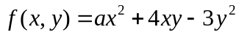 is harmonic. | L1 | CO1 | [2M]
2 | Define essential singularity of an analytic function. | L1 | CO2 | [2M]
3 | Among the workers in a factory only 50% receive bonus. Among those receiving the bonus 30% are skilled. What is the probability of a randomly selected worker who is skilled and receiving bonus? | L2 | CO3 | [2M]
4 | What is maximum error one can expect to make with probability 0.9, when using the mean of a random sample of size 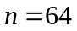 to estimate the mean of a population with 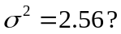 | L2 | CO4 | [2M]
5 | Write few managerial benefits result using quality control. | L1 | CO5 | [2M]
6 | If we can assert with 95% that the maximum error is 0.05 and p is given as 0.2. Find the size of the sample. | L1 | CO6 | [2M]
7 | Prove that 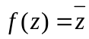 is not analytic at any point. | L1 | CO1 | [2M]
8 | State the central limit theorem. | L1 | CO4 | [2M]
9 | Define null and alternative hypotheses. | L1 | CO6 | [2M]
10 | What are the traditionally used quality control techniques? | L2 | CO5 | [2M]
Part – B Max.Marks:50
ANSWER ANY FIVE QUESTIONS. EACH QUESTION CARRIES 10 MARKS.

 |  |  | BCLL | CO(s) | Marks
11. | a) | Find the analytic function 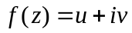, if 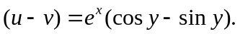 | L1 | CO1 | [5M]
 | b) | If is a harmonic function, show that 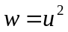 is not harmonic function unless is a constant. | L1 | CO1 | [5M]
12. | a) | Evaluate by Residue theorem, 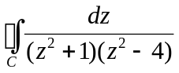 where  is 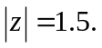 | L2 | CO2 | [5M]
 | b) | Expand 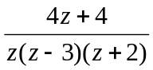 in the region 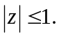 | L1 | CO2 | [5M]
13. | a) | Fit a poisson distribution for the following data and calculate the expected frequencies. | L1 | CO3 | [5M]
  X | 0 | 1 | 2 | 3 | 4
  F(x) | 109 | 65 | 22 | 3 | 1
 | b) | Three machines produces 70%, 20%, and 10% of the total number of a factory. The percentages of defective output of these machines are respectively 4%, 3% and 2%. An item is selected at random and found defective. Find the probability that it is from machine II. | L3 | CO3 | [5M]
14. | a) | A random sample of size 100 is taken from an infinite population having the mean 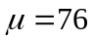 and the variance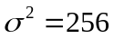. What is the probability that will be between 75 and 78? | L2 | CO4 | [5M]
 | b) | The mean and standard deviation of a population are 11,795 and 14,054 respectively. What can one assert that 95% confidence about the maximum error if 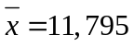 and 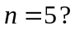 | L1 | CO4 | [5M]
15. | a) | What is a control chart? Discuss the underlying principle in drawing of control charts. | L1 | CO5 | [5M]
 | b) | 15 samples each of size 10 were checked for specifications. The number of defective parts found in each of the samples are given below:  Construct the number defective chart and interpret the chart. | L2 | CO5 | [5M]
  Sample no. | 1 | 2 | 3 | 4 | 5 | 6 | 7 | 8 | 9 | 10 | 11 | 12 | 13 | 14 | 15
  No. of defectives | 1 | 0 | 1 | 3 | 8 | 0 | 3 | 7 | 1 | 0 | 0 | 3 | 1 | 2 | 0
16. | a) | Samples of students were drawn from two universities and from their weights in kgm and standard deviations are calculated. Make a large sample test to test the significance of the difference between the means. | L3 | CO6 | [5M]
   | Mean | S.D. | Size of the sample
  University A | 55 | 10 | 400
  University B | 57 | 15 | 100
 | b) | The daily wages in rupees of skilled workers in two cities are as follows:  Test at 5% level the equality of variances of the wage distribution in the two cities. | L3 | CO6 | [5M]
  City | Size of sample | S.D. of wages in the sample
  City A | 16 | 25
  City B | 13 | 32
17. | a) | If 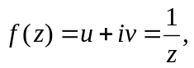 show that the curves 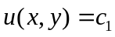 and 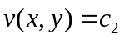 intersect orthogonally. | L1 | CO1 | [4M]
 | b) | Evaluate by Cauchy’s integral formula 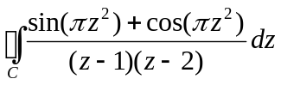  where 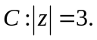 | L2 | CO2 | [3M]
 | c) | If three coins are tossed. Find the probability of getting  - 3 heads ii) 2 heads iii) no heads. | L1 | CO3 | [3M]
18. | a) | The mean height of students in a college is 155 cms and standard deviation is 15 cms. What is the probability that the mean height of 36 students is less than 157 cms? | L1 | CO4 | [4M]
 | b) | What are the causes of product quality variations? | L1 | CO5 | [3M]
 | c) | Experiences have shown that 10% of a manufactured product is of quality what can you say about the maximum error with 95% confidence for 100 items. | L2 | CO6 | [3M]

-- 00 -- 00 –

